**DAILY ONLINE ACTIVITIES SUMMARY**

|  |  |  |  |  |  |  |  |  |
| --- | --- | --- | --- | --- | --- | --- | --- | --- |
| **Date:** | **26th may,2020** | | | | | **Name:** | **Prathusha K A** | |
| **Sem & Sec** | **4th sem &b section** | | | | | **USN:** | **4AL18CS061** | |
| **Online Test Summary** | | | | | | | | |
| **Subject** | | **Design and Analysis of Algorithm.** | | | | | | |
| **Max. Marks** | | **30** | | **Score** | | | **25** | |
| **Certification Course Summary** | | | | | | | | |
| **Course** | **Programming for everybody (getting started with python)** | | | | | | | |
| **Certificate Provider** | | | **Coursera** | | **Duration** | | | **7 weeks** |
| **Coding Challenges** | | | | | | | | |
| **Problem Statement: Write a Java program to remove all 10 in the given array** | | | | | | | | |
| **Status: done** | | | | | | | | |
| **Uploaded the report in Github** | | | | | **yes** | | | |
| **If yes Repository name** | | | | | **https://github.com/prathu47/lockdown-coding** | | | |
| **Uploaded the report in slack** | | | | | **yes** | | | |

Online Test Details: (Attach the snapshot and briefly write the report for the same)

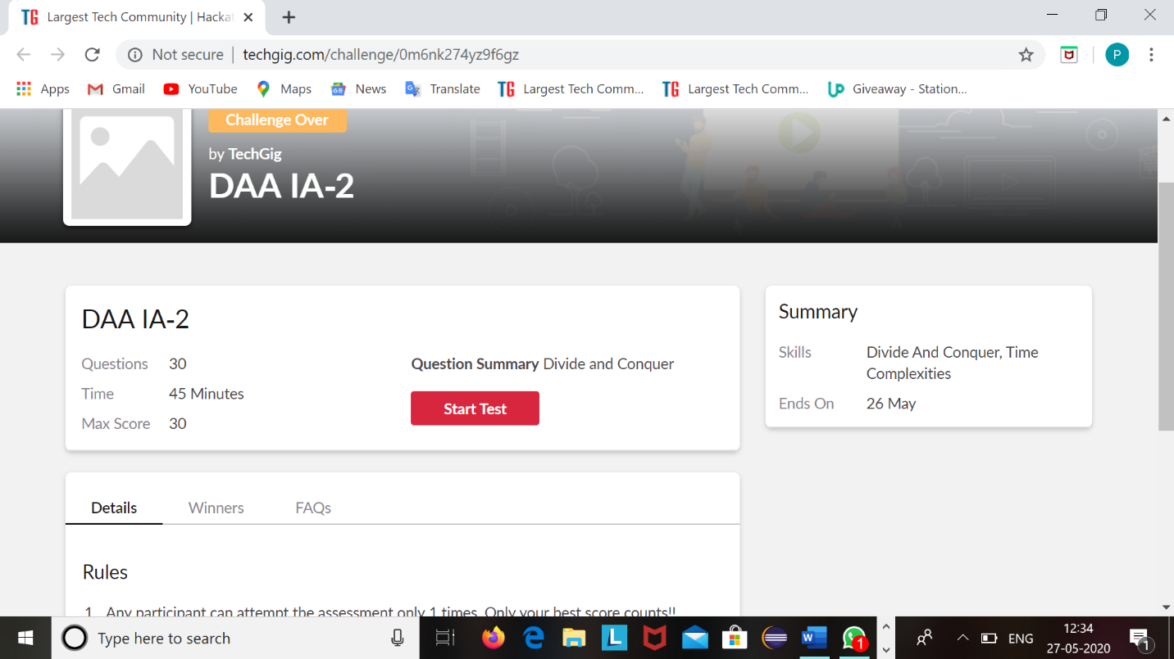

Design and analysis of algorithm 2 nd internal was conducted today at 9:15-9:55 .On the topic of divide and conquer ,time complexities which is of 30 multiple choice questions with time limit of 45 minutes.

The above snapshot is the result sheet which was sent to us by the Techgig team.

Certification Course Details: (Attach the snapshot and briefly write the report for the same)

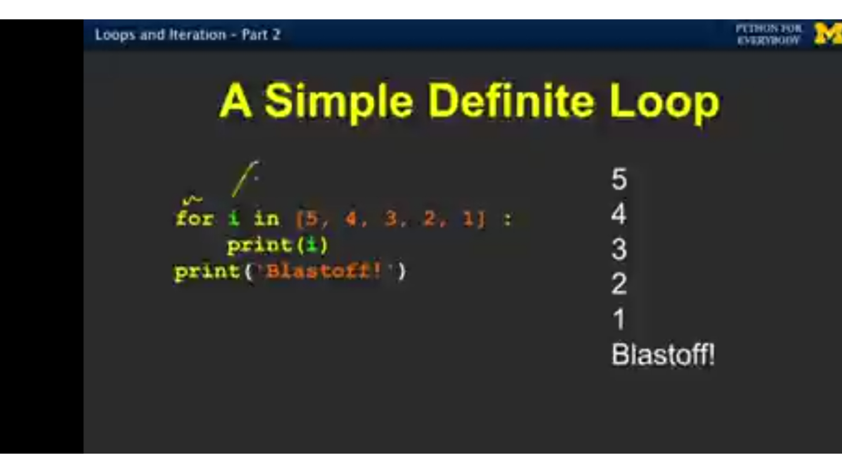

The course I have chosen during the lockdown period is programming for everybody. Since I had previously knew few topics about python iam continuing this course.Since python is gaining a lot of interest in coding platform I have preferred to choose this course.

Coding Challenges Details: (Attach the snapshot and briefly write the report for the same)

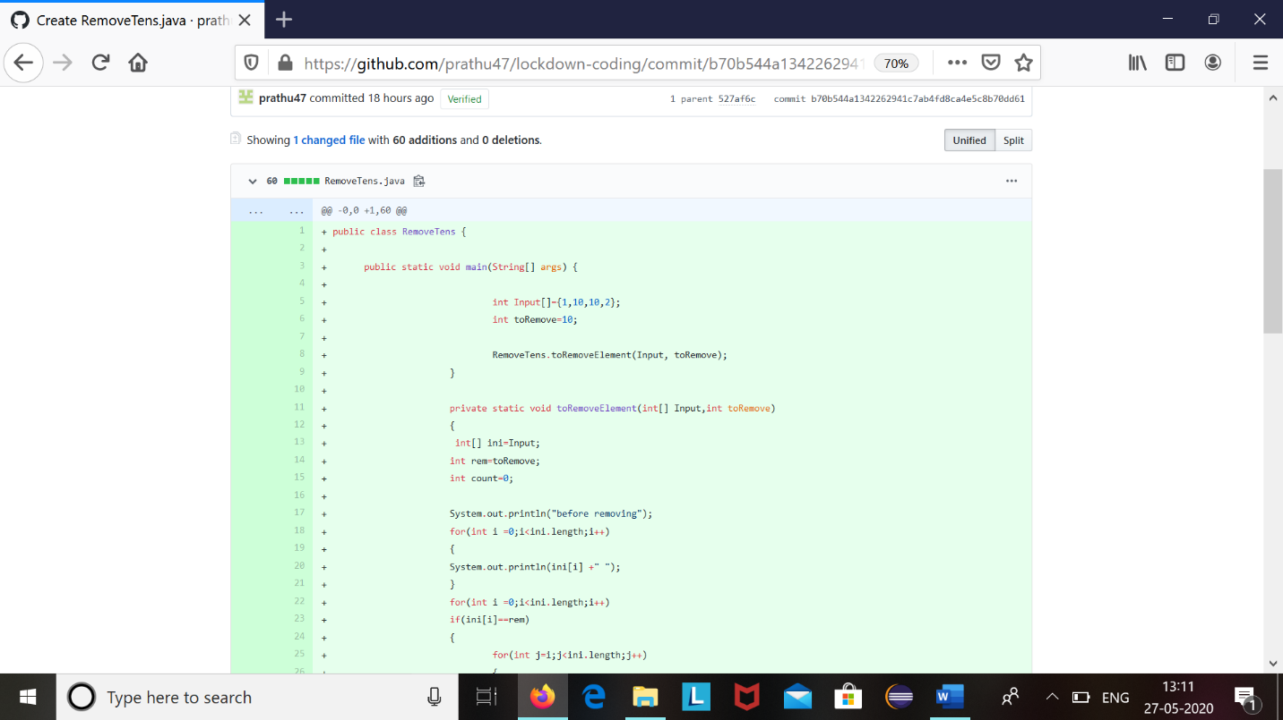

The question we had received today was :

Write a java program to remove all 10 in the given array.

Code:The above snapshot is the code which I have uploaded in my github repository.